# Task on IAM:

1) Create one IAM user and assign ec2,s3 full access role.

Step: go to IAM service

2)create users

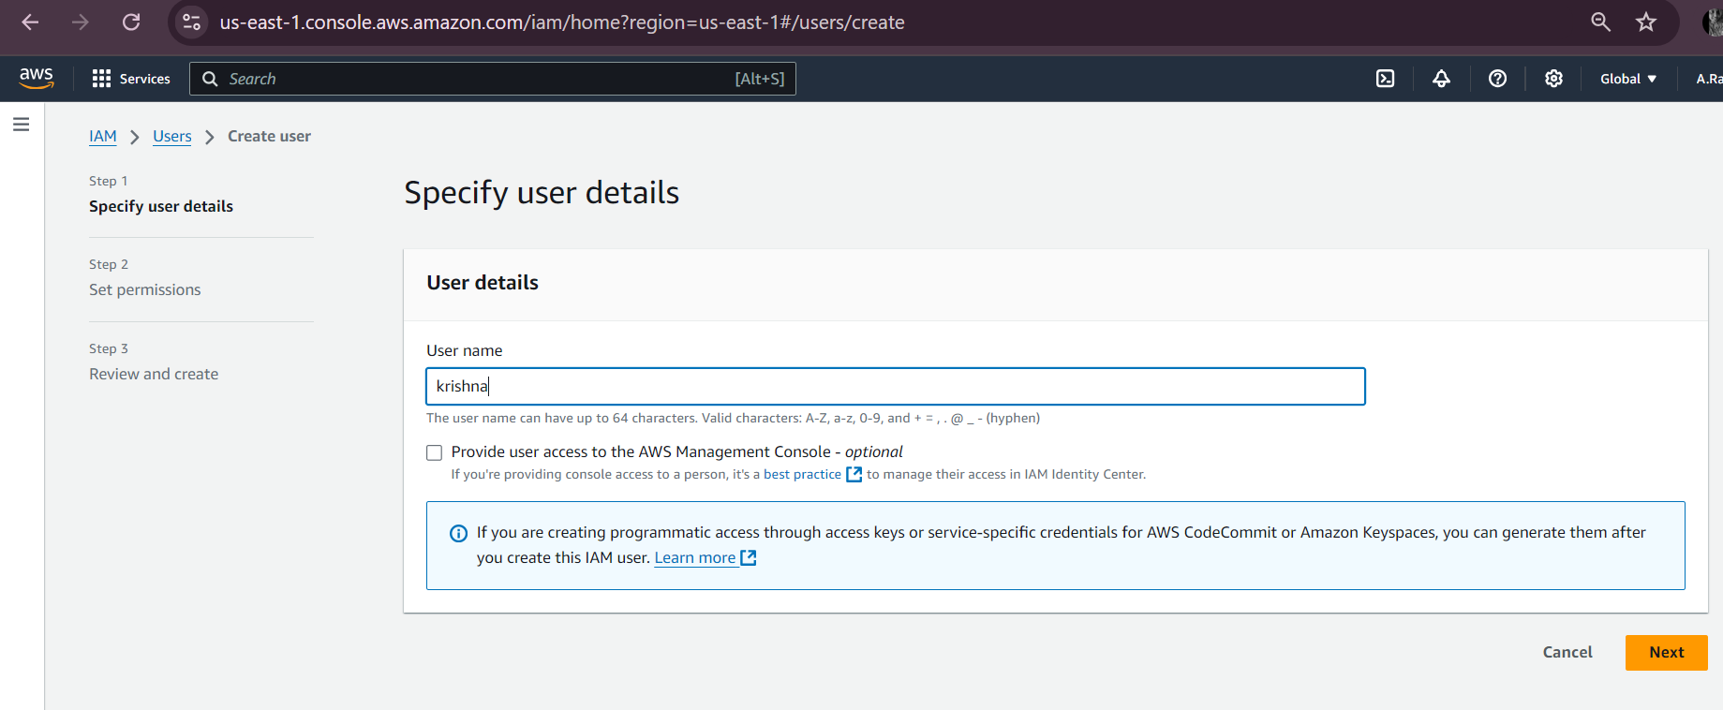

4) Created the user

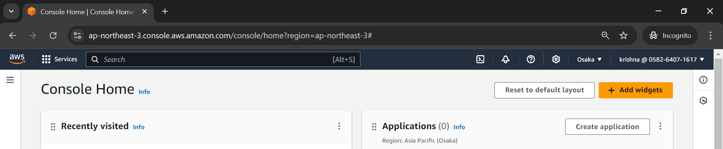

5)User has ec2 full access and s3 full access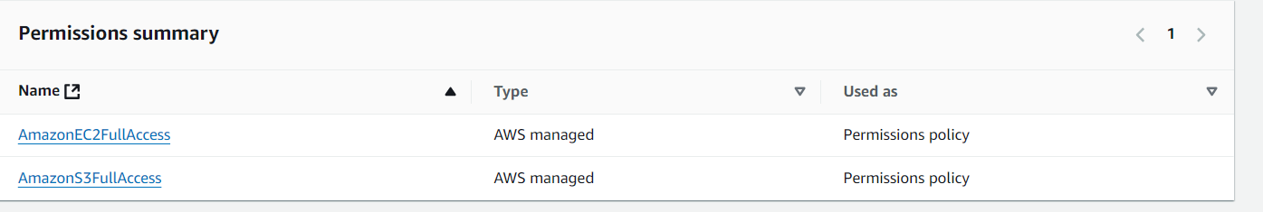

2) Create one Group in IAM and Assign Read access for ec2. 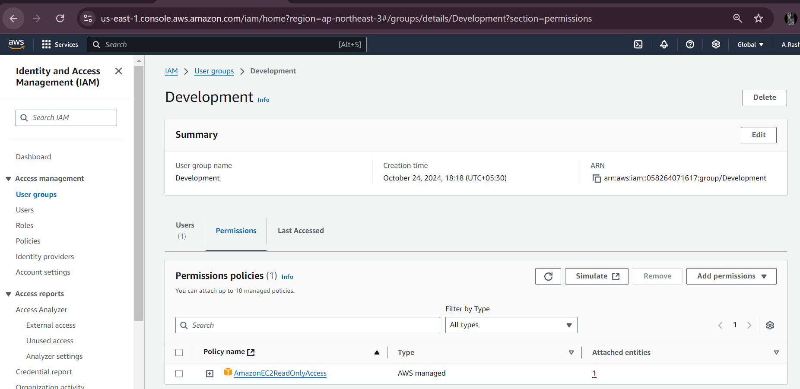

3) Create a new user with name DevOps and add to the group created in task2

Created development usergroup in task2

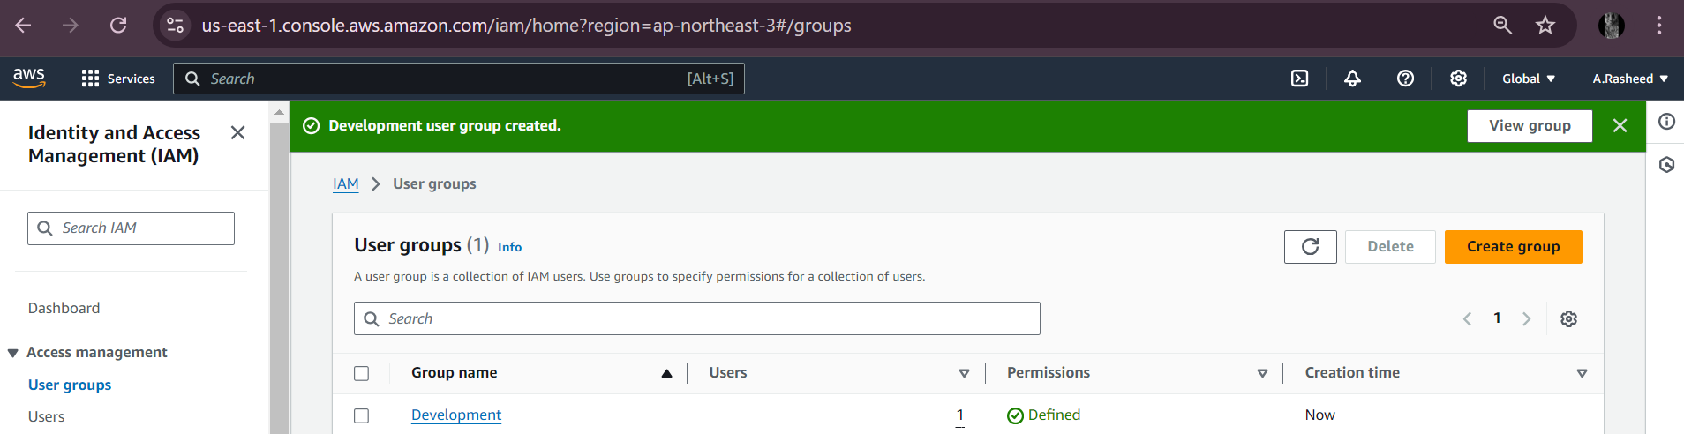

Create user “Devops”

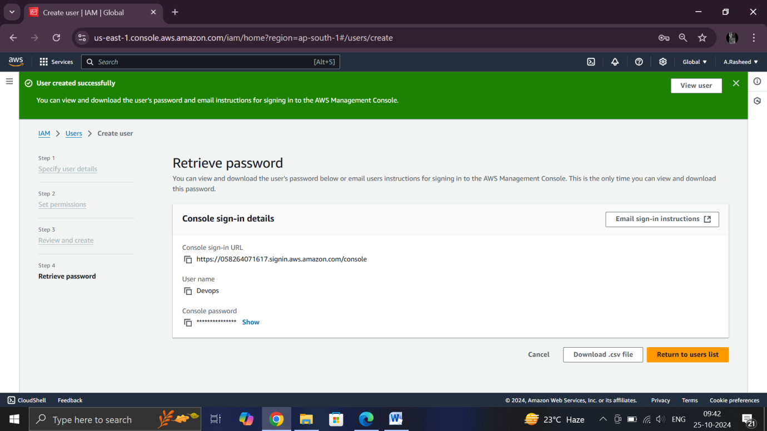

Add the user “devops” to the development group 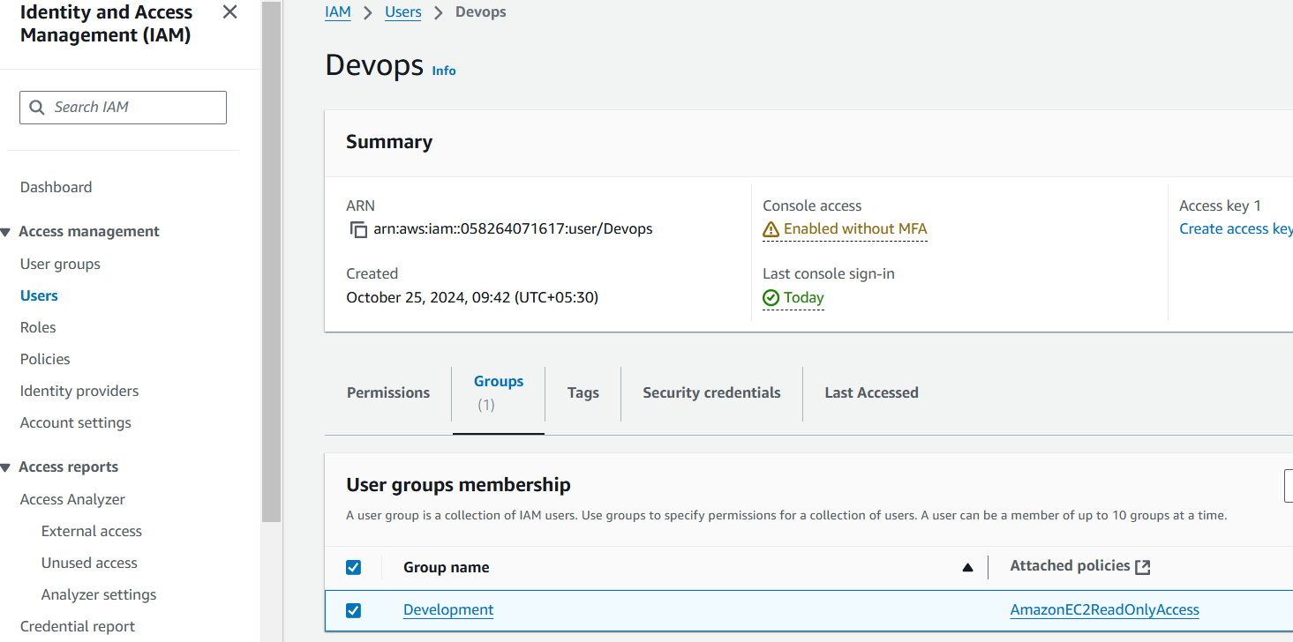

In development we can see new user has added that is “devops”

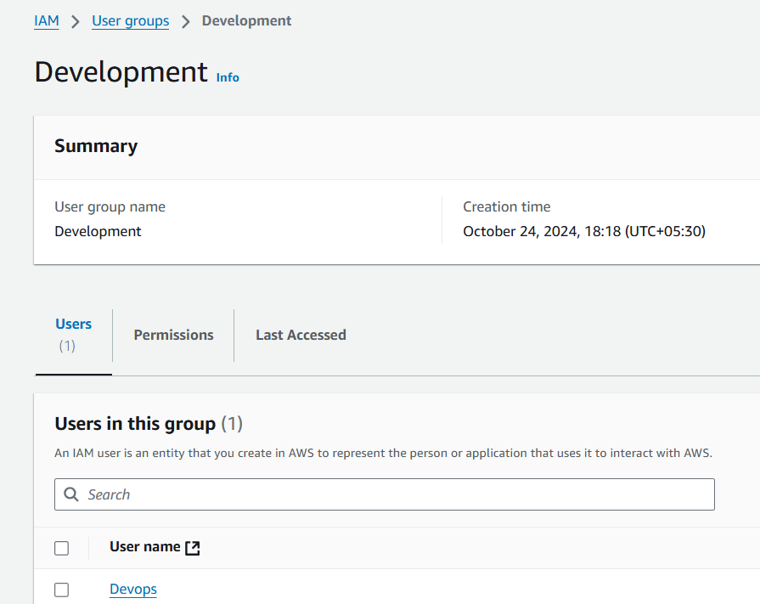

4) Write a bash script to create a IAM user with VPC full access.

Configuring aws cli

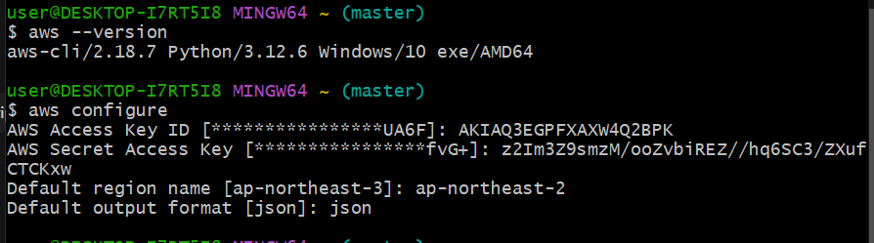

Created bash script to create user with full VPC acess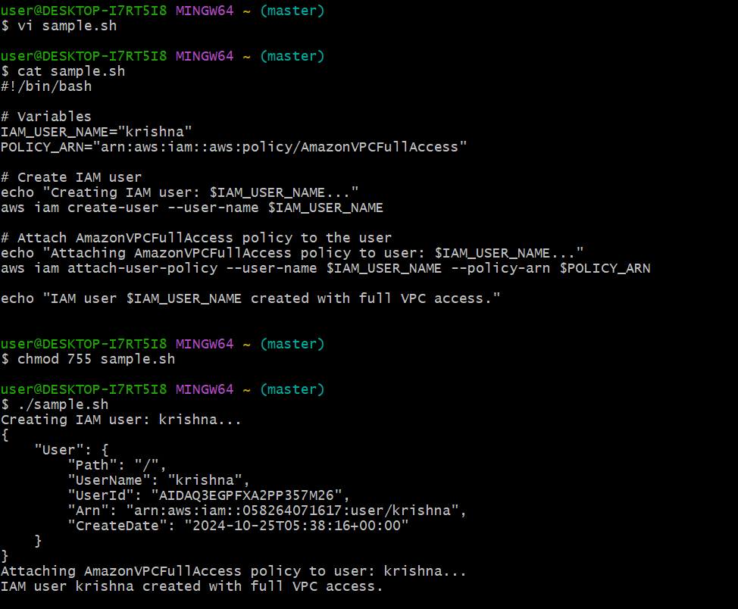

After the execution ,we can check that user has added with vpc full access

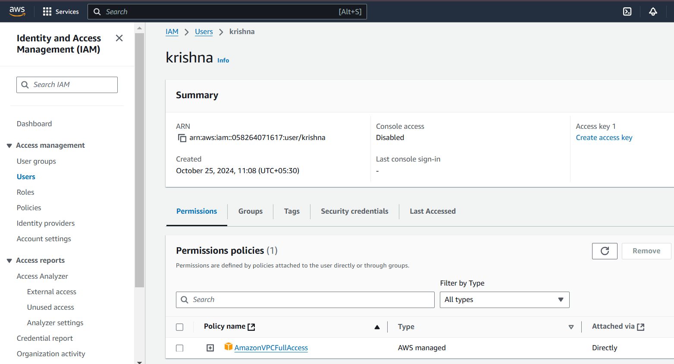

5) Create a IAM policy to access ec2 for a specific user in specific regions only.

Go to IAM service

In IAM,select policy

Create policy

Select ec2,all resources and all actions

In json add the below script for specific region

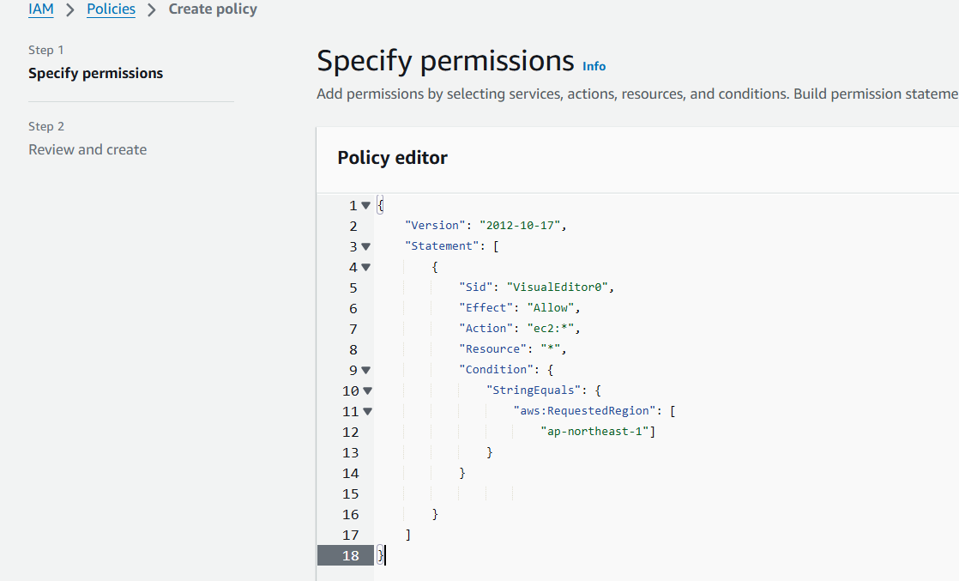

Click next,Add policy name

We can see the policy created 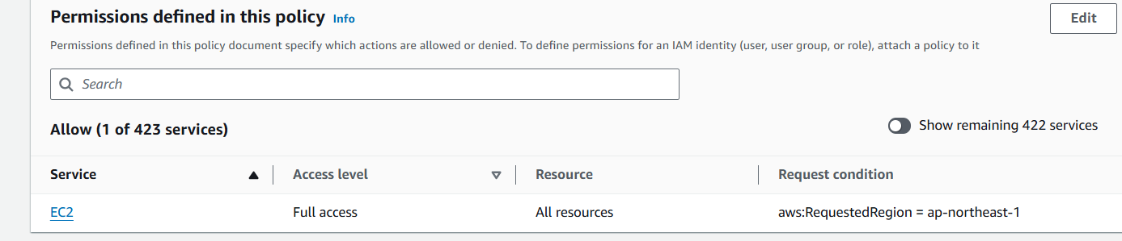

Create the policy.

Now go the users,

Select which user you want to add the policy

